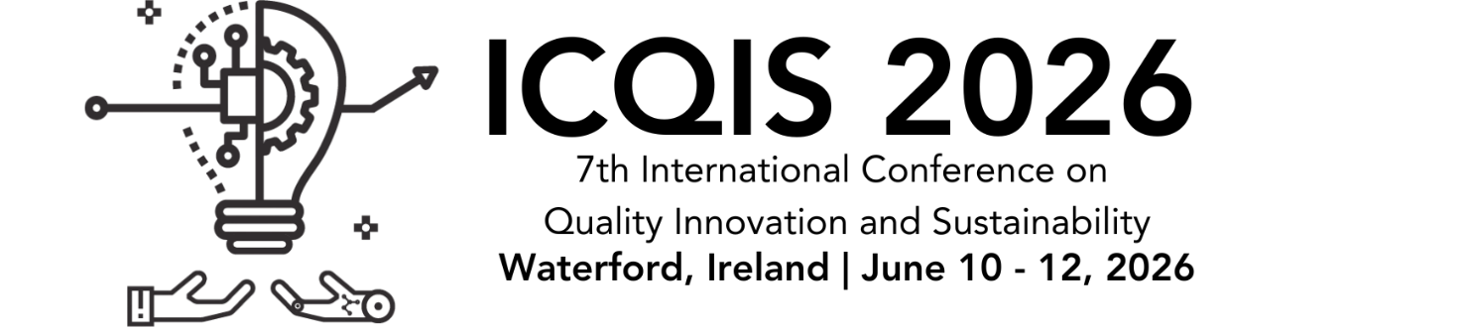

ABSTRACT
TITLE:
AUTHORS: Surname, name1; Surname, name2; …
Affiliation:
Contact Person:
E-mail:
ABSTRACT
This paper is a self-explained example of the format in which the abstract should be submitted to the 7th International Conference on Quality Innovation and Sustainability which will take place in Waterford, Ireland on June 10 – 12, 2026. Please, write an abstract (maximum 300 words) which accounts briefly and clearly for the objectives, contents and conclusions of the work. It should be self-comprehensive without references to the paper. Therefore, figures, tables or bibliographical references should not be referred. This abstract may be written in English. All the accepted abstracts will be published in the Abstract Book.
KEYWORDS: maximum 5

